Project Development Phase
Model Performance Test

Date | 01 October 2026
Team ID | SWTID-2026-4457
Project Name | Script-Controlled ACL – Restrict Record Access Based on Field Value
Maximum Marks

Model Performance Testing:
Project team shall fill the following information in model performance testing template.
S.No. | Parameter | Values | Screenshot
1. | Model Summary | ServiceNow security setup for record-level access control using a script-controlled ACL on the Institution Details table (u_institution_details), with roles bb1 (Read), bb2 (Create), bb3 (Write) and bb4 (Delete).  Note : A user can access the record only when the ACL script evaluates to true (role and Branch = EEE condition met); otherwise access is denied and no records are shown. | 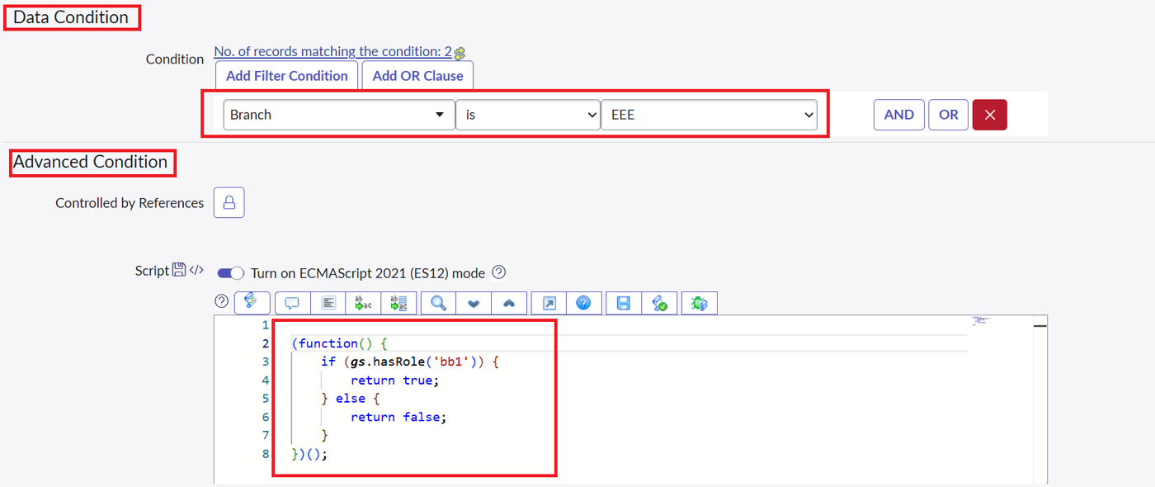  Screenshot: Read ACL with data condition and script
2. | Accuracy | Training Accuracy - N/A (rule-based ACL, no training)  Validation Accuracy - 100% (18 of 18 access decisions correct: bb1 user, user without role and admin, checked against 6 records) | 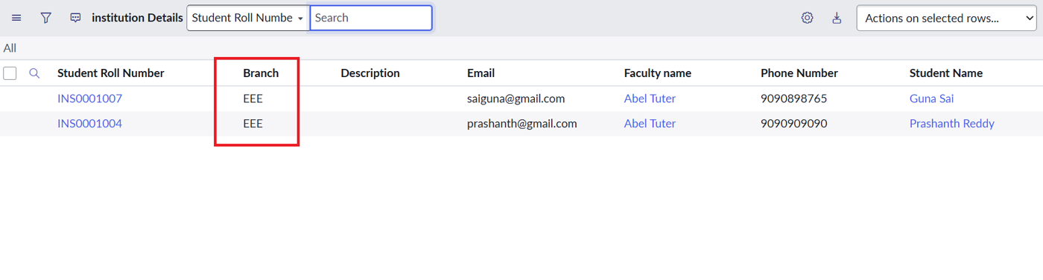  bb1 user list (2 EEE records)  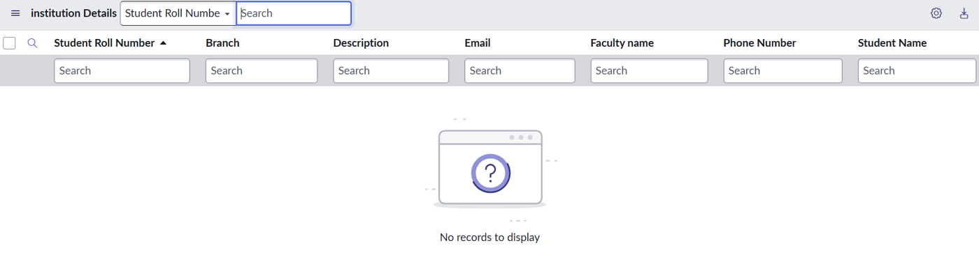  No-role user (No records to display)  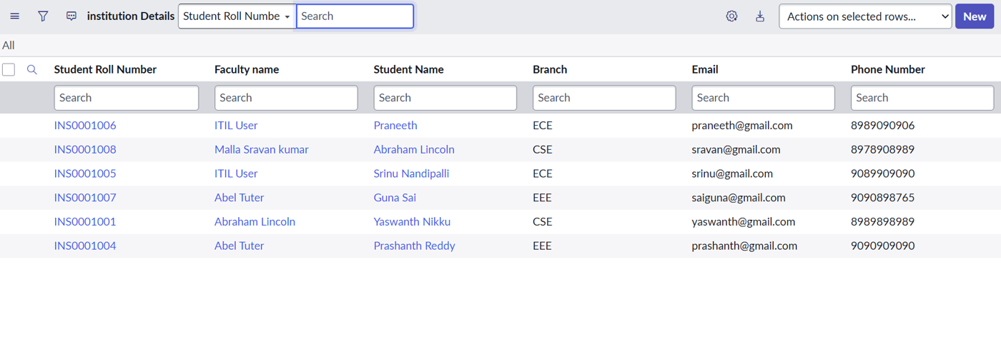  Admin list (6 records)
3. | Confidence Score (Only Yolo Projects) | Not applicable (not a YOLO project).  Class Detected - Access decision: Allowed (script returns true) or Denied (script returns false).  Confidence Score - Deterministic: 100% for the tested roles. | 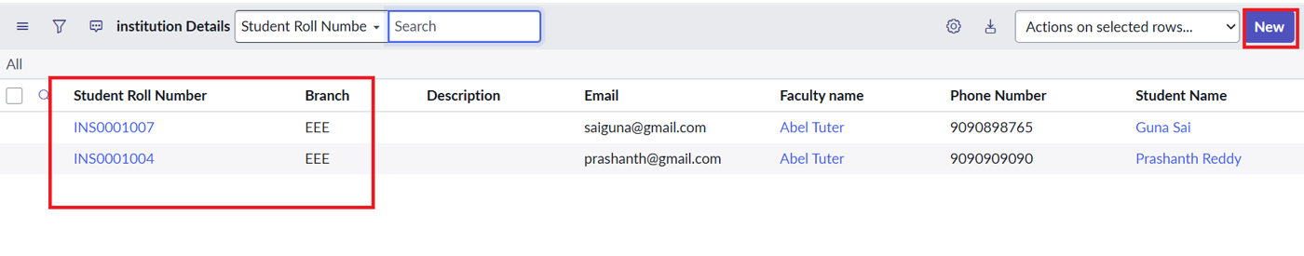  Create ACL verification: New button for bb2  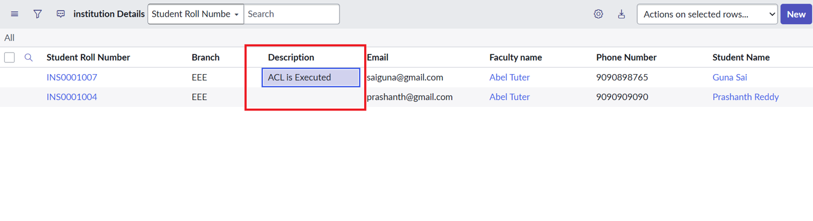  Write ACL verification: inline edit for bb3  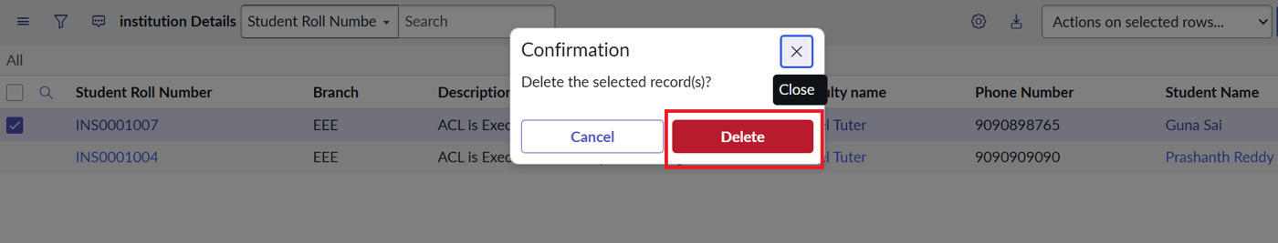  Delete ACL verification: confirmation and delete for bb4

